GARRAS AND SITHNEY  PRIMARY SCHOOLS | 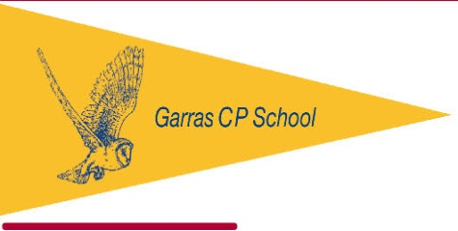

Monday, 21 November 2016
Dear Parents / Guardians,
As part of our PE curriculum this term we are learning about Gymnastics alongside Real PE. We have an exciting opportunity for all children in school to visit Swallows Gymnastics club in Helston where they will have access to an hour long coached gymnastics session using the amazing facilities offered by this local club. This exciting trip will be funded through the sports premium funding to enable all children to gain access to specialist sporting facilities within the locality. The children will experience a tailored Key Steps Gymnastics session alongside use of the wider Gymnasium equipment. This will be delivered by the qualified coaches at Swallows. There will be an opportunity for some children to take part in a follow up Key Steps Gymnastics competition in the second week back after the Christmas break (more details to follow in the New Year).
The sessions will take place on Friday 2nd December and each class will have the following time slots. Children will be at school as normal outside of these time slots.
Reception / Busy Zone 10.45 – 11.45
Year 1 and 2 / Wonder Zone 11.45 – 12.45
Year 3 and 4 / Smart Zone 13.00 – 14.00
Year 5 and 6 / Study Zone 14.00 – 15.00
Due to the logistics of the day please can all children come with a packed lunch (FSM & KS1 provided), appropriate PE kit and a drink. Children will need to come to school for normal start time, please allow a 15 minute delay for Study Zone on their return at the end the school day.
Many thanks,
Matt Birchall
(PE Co-ordinator)

